# **SLIPPs Barrows card game.**

The game is proposed to the students, in original P4 format.

The Barrows card game method is based on problem learning (PBL)1. Drawing on PBL philosophy the game centers around the development of a learning logic path that starts from a problematic situation (e.g. care management or patient condition issue). From the initial situation a sequence of related situations or issues are presented that exemplify the ‘problem’ in various forms. The students are tasked with considering these and identifying or choosing solutions offered- (correct or incorrect).

The SLIPPs Barrows card game focuses on fundamentals of care, starting from a situation relating to communication. The card game then develops and evolves to present a range of situations and options for answers. These assist students in linking the situations and solutions to codes of practice, notions of safe and ethical practice and person centeredness.

1. Barrows H.S. & Tamblyn R.M. (1977) The portable patient problem pack (P4). A problem-based learning unit. Journal of Medical Education 52, 1002–1004

# **Situation 1: Card 1**

**Situation card**

**Front Back**

**Situation 1**

You are doing an internship /placement in a general surgery ward, and together with the senior nurse on duty you are taking care of an 80-year-old man. He is on the third post-operative day, and was completely autonomous and self-caring before the operation.

The nurse tells you that you are assigned to this patient and responsible for his care.



As soon as the morning hand over is finished, the nursing staff starts planning the morning's work.

The senior nurse on duty tells you that it is a priority that the patient assigned to you reacquire his complete autonomy as soon as possible.

**What will you do?**

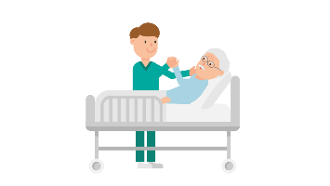



# **Situation 1: Card 2 (Answer A)**

# 

**Situation 1: Answer A**

**Front Back**

**CORRECT**

Taking charge of a patient and the implementation of appropriate and safe care interventions cannot be separated from the collection / verification of data, indispensable for identifying the patient's needs and goals of care, and for planning nursing interventions

For further information on what should be the correct professional action in these situations, consult the Nursing Code of practice or ‘Deontological’ Code, any role or Professional Profiles, the Nursing process, care planning or nursing or principles used in your country or organisation.

Check the assessment data collected on admission to the ward.

Take note of: the type of surgery the patient has undergone, the therapy in progress, and the principals of the nursing care plan (e.g. nutrition, mobilisation, psycho-social aspects, elimination, mobilisation etc)

Before planning and implementing any intervention, including that of mobilization.



# 

# **Situation 1: Card 3 (Answer B)**

**Situation 1: Answer B**

**Front Back**

**INCORRECT**

Taking charge of a patient and the implementation of appropriate and safe care interventions cannot be separated from the collection / verification of data, indispensable for identifying the patient's needs and goals of care, and for planning nursing interventions

 For further information on what should be the correct professional action in these situations, consult the Nursing Code of practice or ‘Deontological’ Code, any role or Professional Profiles, the Nursing process, care planning or nursing or principles used in your country or organisation.

Enter the room and explain to the patient that you have to mobilize him- assist him to get out of bed, walk and sit in a chair

You explain to the patient that the nurse in charge instructed you to do this.



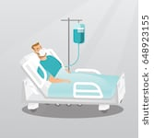



# **Situation 2: Card 1**

**Situation card**

**Front Back**

**Situation 2**

You have reviewed the patient’s records:

* He is a diabetic patient on insulin therapy at home,
* He is mildly obese/overweight,
* He has undergone abdominal surgery,
* He has no cognitive or mobility impairment.

You discuss with the nurse tutor and agree the start of the patient's mobilization program. This includes some light exercise and active mobilization to a sitting position.

You go into the room to share the day's program with the patient.

He complains of dizziness and declares aloud that he intends to postpone the resumption of mobilization.

The nurse tutor asks you to find a solution.

**What will you do?**





# **Situation 2: Card 2 (Answer A)**

# 

**Situation 2: Answer A**

**Front Back**

# 

**CORRECT**

It is important to listen to the patient and understand the reasons for refusal, which may be justified. The patient should always be involved in defining goals and agreeing interventions. The patient's early mobilization must always be implemented safely: this implies gradual and monitored mobilization in relation to available patient data. Subject to monitoring vital signs and possible physiotherapy consultation.

Forcing the patient to get up against his will by lifting him would not only expose him to risks such as falling, but would also compromise the establishment of a relationship of trust

For further information on correct professional action, consult relevant Nursing Codes of practice, Patient handling guidelines, Fundamentals of Care framework and Nursing theories, or principles used in your country or organisation.

Being an elderly post-operative patient who complains of dizziness, you decide not to mobilize him and try to understand the reasons for his refusal.

You listen and observe him and measure his vital signs.

You decide to postpone mobilization.

# 

# 

# E:\SLIPPS\slipps-194x230 - Copy.png

# **Situation 2: Card 3 (Answer B)**

**Situation 2: Answer B**

**Front Back**



**INCORRECT**

It is important to listen to the patient and understand the reasons for refusal, which may be justified. The patient should always be involved in defining goals and agreeing interventions. The patient's early mobilization must always be implemented safely: this implies gradual and monitored mobilization in relation to available patient data. Subject to monitoring vital signs and possible physiotherapy consultation.

Forcing the patient to get up against his will by lifting him would not only expose him to risks such as falling, but would also compromise the establishment of a relationship of trust

For further information on correct professional action, consult relevant Nursing Codes of practice, Patient handling guidelines, Fundamentals of Care framework and Nursing theories, or principles used in your country or organisation.

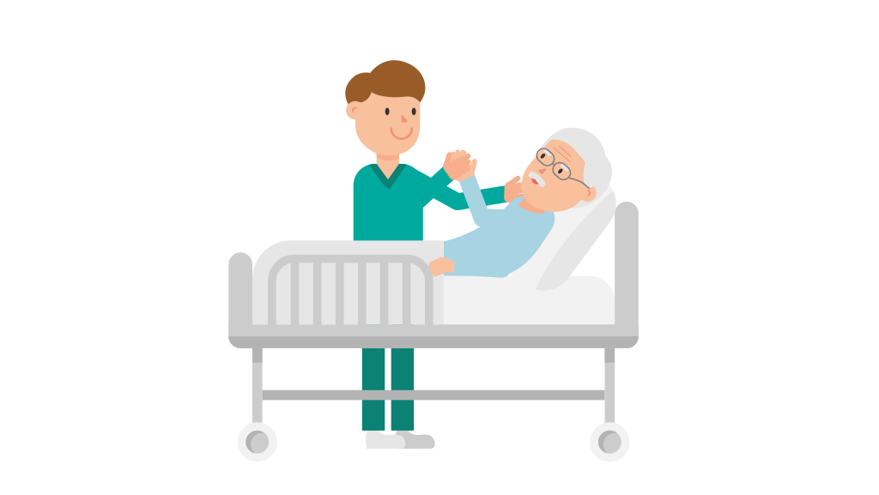

You decide to insist the patient gets up and is mobile. You think he may just need encouragement.

You assist him to mobilize to a sitting position on the bed as an agreed goal.





# **Situation 3: Card 1**

**Situation card**

**Front Back**

**Situation 3**

Blood pressure measurement reveals the patient has slight hypotension. However your reassurance and the spontaneous disappearance of the dizziness calms the patient.

After an hour, the patient rings the call bell/buzzer.



You answer the call and in his room listen to the patient so you can understand his needs. The patient tells you that he feels; pain in the lower abdomen, as if he has not emptied his bladder completely, and that he "feels a very strongly urge to urinate".

**What will you do?**





# **Situation 3: Card 2 (Answer A)**

# 

**Situation 3: Answer A**

**Front Back**

# 

**CORRECT**

It is crucial to quickly establish a relationship of trust with the patient, in order work in partnership on the care process and provide safe, quality care.

Responding immediately to a call and putting yourself in active listening mode is the first step in creating a good nurse / patient relationship. It is counterproductive to the development of a correct therapeutic relationship to be vague when asked questions and is much more appropriate and helpful to deepen the patient's knowledge of the situation.

For further information on the nurse / patient relationship, consult relevant Nursing Codes of practice, any specialty specific guidelines or protocols, the Fundamental Nursing Care Framework and relevant nursing theories. For urology and catheterisation information guidelines see for example , [https://nurses.uroweb.org/wp-content/uploads/2013_EAUN_Guideline_Milan_2013-Lr_DEF.pdf](https://eur02.safelinks.protection.outlook.com/?url=https%3A%2F%2Fnurses.uroweb.org%2Fwp-content%2Fuploads%2F2013_EAUN_Guideline_Milan_2013-Lr_DEF.pdf&data=02%7C01%7Calison.steven%40northumbria.ac.uk%7Cbf7ea38f03e84517376708d7943f25f9%7Ce757cfdd1f354457af8f7c9c6b1437e3%7C0%7C0%7C637140871810106410&sdata=mtVaIYcT4Hwsm6mwUx4VCoJhf2CXLnvD%2Fyz9K7M659Y%3D&reserved=0)

Listen carefully to the patient and try to understand his needs. Given he is a post-operative patient reporting pain in the hypogastric area and a feeling of incomplete bladder emptying, you suspect urinary retention.

You palpate the suprapubic and pelvic region and detect bladder overextension.

You then communicate these results to your tutor and propose a portable bladder scan on the ward to establish the volume of urine and then catheterisation. You perform the scan, followed by intermittent catheterization. At the same time reassuring the patient that initial urinary retention is common after the removal of a bladder catheter.

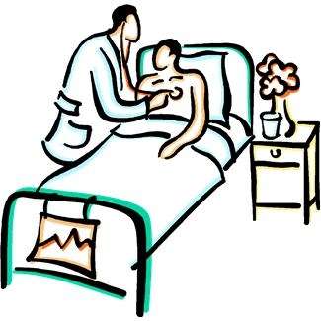

# 



# **Situation 3: Card 3 (Answer B)**

**Situation 2: Answer B**

**Front Back**



**INCORRECT**

It is crucial to quickly establish a relationship of trust with the patient, in order work in partnership on the care process and provide safe, quality care. Responding immediately to a call and putting yourself in active listening mode is the first step in creating a good nurse / patient relationship. It is counterproductive to the development of a correct therapeutic relationship to be vague when asked questions and is much more appropriate and helpful to deepen the patient's knowledge of the situation.

For further information on the nurse / patient relationship, consult relevant Nursing Codes of practice, any specialty specific guidelines or protocols, the Fundamental Nursing Care Framework and the theories, specifically, of Virginia Henderson, Dorothea Orem, Hildergard Peplau, Ida Jean Orlando and Joyce Travelbee.

Since you know it is important for the patient to get up, be mobile and regain his autonomy, do not pay much attention to his complaints.

You think that perhaps a little persuasion is needed, and all the more reason for him to get up now that he feels pain because he needs to urinate.

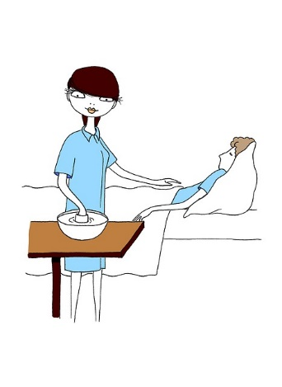









# **Situation 4: Card 1**

**Situation card**

**Front Back**

**Situation 4**

After a few hours of performing intermittent catheterisation, which confirmed urinary retention, the patient rings the bell/buzzer again:

you enter the room where the relatives of the other patient are present, and your patient, who has not yet begun to mobilize , reports that he feels again the urge to urinate.



You decide, then, to bring him the urinal and try to convince him to position himself in the wheelchair. The patient consents.



**How will you do this?**



# **Situation 4: Card 2 (Answer A)**

# 

**Situation 4: Answer A**

**Front Back**

# 

**CORRECT**

Respect for the privacy and dignity of the client is a fundamental value of the nursing profession, and must always be respected in any situation.

Leaving the patient alone, exposed, in a moment of intimacy, damages his dignity and his privacy. We must always ensure comfort and privacy, through the adoption of appropriate measures (eg use of a screen). Moreover, before leaving the room, it is necessary to make sure that the patient knows how to use the devices supplied to him.

For further information on the topic, consult the Professional Deontological Code /code of conduct and the Fundamental Nursing Care Framework.

Using all the appropriate safety measures, position the patient on the wheelchair.

Then: place a screen around the patient or draw the curtains, or accompany the patient to the bathroom making sure the patient is safely positioned (wheel lock, lowered footrest, etc.) Wait nearby within hearing distance for the time needed by the patient, helping him in case of need.





# **Situation 4: Card 3 (Answer B)**

**Situation 4: Answer B**

**Front Back**

**INCORRECT**

 Respect for the privacy and dignity of the client is a fundamental value of the nursing profession, and must always be respected in any situation.

Leaving the patient alone, exposed, in a moment of intimacy, damages his dignity and his privacy. We must always ensure comfort and privacy, through the adoption of appropriate measures (eg use of a screen). Moreover, before leaving the room, it is necessary to make sure that the patient knows how to use the devices supplied to him.

For further information on the topic, consult the Professional Deontological Code and the Fundamental Nursing Care Framework.

Give the urinal to the patient and leave.







# **Situation 5: Card 1**

**Situation card**

**Front Back**

**Situation 5**

The mobilization program is finally started: the patient is assisted for short periods to getting up, stand and take some steps.

Towards the end of the morning he asks you for help to go to the bathroom. You accompany him and after helping him onto the toilet, you leave the bathroom and wait behind the door.

The effort to evacuate his bowels has caused pain and a vasovagal reaction: he calls for your help complaining of pain and dizziness and tells you that "he can't do it".



**What will you do?**



# E:\SLIPPS\slipps-194x230 - Copy.png

# **Situation 5: Card 2 (Answer A)**

# 

**Situation 5: Answer A**

**Front Back**

# 

**CORRECT**

The patient's early mobilization must always be implemented guaranteeing his safety: this implies gradual and modulated mobilization in relation to patient data, subject to detection of vital parameters and possible physiotherapy consultation, and using appropriate moving and handling procedures . Forcing the patient to stand or lifting him would expose him to risks of falling and health, and would irreparably compromise the possibility of establishing a relationship of trust.

To deepen knowledge on prevention and reduction of the risk falls, consult the Hospital Guidelines and / or Professional Orders, as well as the scientific literature on the subject. Also consult relevant Nursing Codes of practice, any specific guidelines or protocols, or Fundamental Nursing Care Frameworks to deepen understanding of intra-and inter-professional collaboration.

Without leaving the patient alone, you ring the emergency bell and ask for help (support staff or colleagues). During this time you are constantly evaluating the patient.

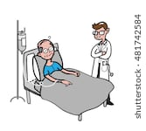

# 





# **Situation 5: Card 3 (Answer B)**

**Situation 5: Answer B**

**Front Back**



**INCORRECT**

The patient's early mobilization must always be implemented guaranteeing his safety: this implies gradual and modulated mobilization in relation to patient data, subject to detection of vital parameters and possible physiotherapy consultation. Forcing the patient to stand or lifting him would expose him (and you) to risks and would irreparably compromise the possibility of establishing a relationship of trust.

To deepen knowledge on prevention and reduction of the risk falls, consult the Hospital Guidelines and / or Professional Orders, and approporiate the scientific literature.  Also consult relevant Nursing Codes of practice, any specific guidelines or protocols, or Fundamental Nursing Care Frameworks to deepen understanding of intra-and inter-professional collaboration and approporiate moving and handling procedures.

You decide that you cannot call for help and then wait for assistance, so you lift the patient to standing and help him onto the bed.









# **Situation 6: Card 1**

**Situation card**

**Front Back**

**Situation 6**

The nurse on duty looks into the room and tells you that she cannot afford to interrupt what she is doing, and urges you to "get by on her own."



**What will you do?**





# **Situation 6: Card 2 (Answer A)**

# 

**Situation 6: Answer A**

**Front Back**

**CORRECT** 

To mobilize the patient without using the appropriate aids, or without being sure of being able to carry out the maneuver safely, exposes the patient to important health risks. Moreover, this also puts the staff member undertaking any manourver at risk, since the movement of patients not carried out correctly can have long term physical repercussions .

To deepen your knowledge and skills regarding the correct mobilization of the patient, consult the relevant Hospital guidelines or protocols, and / or Professional Orders, as well as the scientific literature on the subject.

You decide, however, not to mobilize the patient alone, but ask a colleague of yours to go and look for another more senior or suitably qualified member if staff, who can help you.



# E:\SLIPPS\slipps-194x230 - Copy.png

# **Situation 6: Card 3 (Answer B)**

**Situation 6: Answer B**

**Front Back**

**INCORRECT**

To mobilize the patient without using the appropriate aids, or without being sure of being able to carry out the maneuver safely, exposes the patient to important health risks. Moreover, this also puts the staff member undertaking any manourver at risk, since the movement of patients not carried out correctly can have long term physical repercussions .

To deepen your knowledge and skills regarding the correct mobilization of the patient, consult the relevant Hospital guidelines or protocols, and / or Professional Orders, as well as the scientific literature on the subject.

You decide, at this point, to mobilize the patient alone, putting him on the wheelchair so as to bring him back to bed.

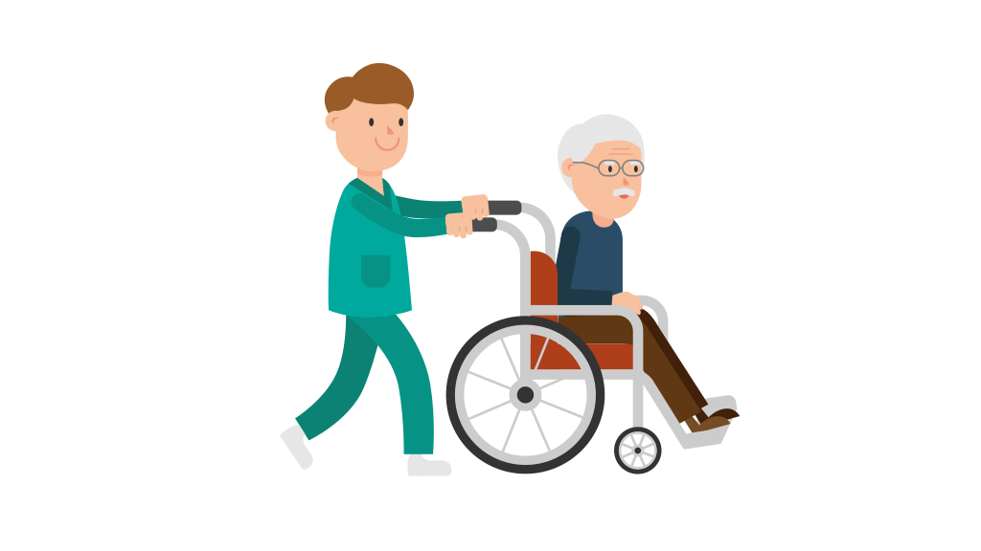





# **Situation 7: Card 1**

**Situation card**

**Front Back**

A staff member Health care assistant (HCA) comes to help you, and together you manage to bring the patient back to his bed.

The patient begins to complain to you about how very unwell he felt during the procedure, and how he cannot understand why the procedure was needed.



**How do you decide to communicate with the patient?**

**What do you say?**



# **Situation 7: Card 2 (Answer A)**

# 

**Situation 7: Answer A**

**Front Back**

# 

**CORRECT**

To establish a correct patient / nurse relationship it is important to listen to the patient and to know how to provide adequate feedback.

It is important to know how to explain the situation, the benefits and the risks that are encountered during the execution of a certain maneuver, so as to make the patient feel safe and make him gain confidence in the Healthcare system or organisation that is treating him.

If you are unable to provide adequate explanations, or do not feel confident to do so you can ask for the support of a colleague or a superior. For further information consult relevant Nursing Codes of practice, any specialty specific guidelines or protocols, Fundamental Nursing Care Frameworks and the theories.

You listen to the patient and explain to him that after the surgery, the body uses physiological compensatory mechanisms and that moments of mild discomfort during mobilisation are part of the recovery phase.



# E:\SLIPPS\slipps-194x230 - Copy.png

# **Situation 7: Card 3 (Answer B)**

**Situation 7: Answer B**

**Front Back**



**INCORRECT**

To establish a correct patient / nurse relationship it is important to listen to the patient and to know how to provide adequate feedback.

It is important to know how to explain the situation, the benefits and the risks that are encountered during the execution of a certain maneuver, so as to make the patient feel safe and make him gain confidence in the Healthcare system or organisation that is treating him.

If you are unable to provide adequate explanations, or do not feel confident to do so you can ask for the support of a colleague or a superior. For further information consult relevant Nursing Codes of practice, any specialty specific guidelines or protocols, Fundamental Nursing Care Frameworks and the theories.

Listen to the patient and explain that the nurse in charge ordered you to perform the procedure, and that you were flowing what they told you to do.





# **Situation 8: Card 1**

**Situation card**

**Front Back**

**Situation 8**

At the beginning of the afternoon shift on the following day, the patient you are treating rings the bell. You immediately feel what he needs and he complains of pain.



**What will you do?**





# **Situation 8: Card 2 (Answer A)**

# 

**Situation 8: Answer A**

**Front Back**

**CORRECT**

A patient's pain must always be taken seriously, in whatever situation it occurs.

Validated scales exist for the correct evaluation of pain, and there are guidelines that must be known and applied. At the end of the pain assessment you can proceed with the recommended treatment in accordance with the guidelines and advice from senior staff (potentially including doctors).

For further information on the subject, consult the Hospital Guidelines or protocols, and / or Professional Orders, and the scientific literature on the subject.

Listen to the patient and ask them to explain exactly where he is in pain, what exactly he feels and evaluate the pain using a suitable scale.

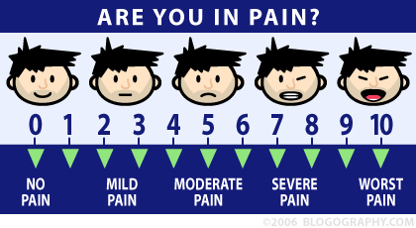

# 



# **Situation 8: Card 3 (Answer B)**

**Situation 8: Answer B**

**Front Back**

**INCORRECT**

A patient's pain must always be taken seriously, in whatever situation it occurs.

Validated scales exist for the correct evaluation of pain, and there are guidelines that must be known and applied. At the end of the pain assessment you can proceed with the recommended treatment in accordance with the guidelines and advice from senior staff (potentially including doctors).

For further information on the subject, consult the Hospital Guidelines or protocols, and / or Professional Orders, and the scientific literature on the subject.

Listen to the patient and ask him to explain exactly where he is in pain, and what he feels exactly.

Identify the most appropriate pain scale to assess intensity, invite him to endure a few more hours to avoid overdoing drugs.

Remind him that he has undergone surgery.

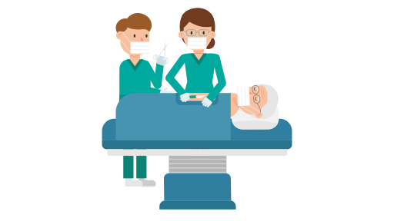





# **Situation 9: Card 1**

**Situation card**

**Front Back**

**Situation 9**

The therapy prescribed for 3:00 pm includes the administration of a gastroprotective drug, an antihypertensive and 10 units of rapid insulin (this is a diabetic patient who at home self-administered insulin for years with the appropriate personal pen, currently available in the ward) . The nurse tutor asks you to take care of it.



**What will you do?**

**How will you undertake the medications administration?**





# **Situation 9: Card 2 (Answer A)**

# 

**Situation 9: Answer A**

**Front Back**

# 

**CORRECT**

Every care intervention, including the administration of medications, cannot disregard the involvement and consent of the patient. Furthermore, it should be implemented with regard not only to purely technical aspect, but also considering relational, physical and psychosocial aspects.



To deepen knowledge, consult relevant Nursing Codes of practice, any specific Hospital guidelines or protocols, and/or Fundamental Nursing Care Frameworks as well as the scientific literature on the subject. Also explore the SLIPP.eu simulation scenarios on the subject available at <https://www.slipps.eu/>

Check the availability of drugs (including the insulin pen) and enter the room equipped with a sphygmomanometer, stethoscope and glucometer. Before administering the medicines you tell the patient about the types of drugs prescribed, measure his blood pressure and blood sugar and tell him the measured values.

In addition, you propose and encourage him to self-administer the prescribed insulin units with his personal pen, making sure he is willing to do so and encouraging him to regain control over a therapeutic act that has always self-administered.





# **Situation 9: Card 3 (Answer B)**

**Situation 9: Answer B**

**Front Back**

**INCORRECT **

Every care intervention, including the administration of medications, cannot disregard the involvement and consent of the patient. Furthermore, it should be implemented with regard not only to purely technical aspect, but also considering relational, physical and psychosocial aspects.



To deepen knowledge, consult relevant Nursing Codes of practice, any specific Hospital guidelines or protocols, and/or Fundamental Nursing Care Frameworks as well as the scientific literature on the subject. Also explore the SLIPP.eu simulation scenarios on the subject available at <https://www.slipps.eu/>

Take the medications trolley, enter the room and administer the therapy as prescribed. Although the patient has been self-administering insulin for 20 years this is not relevant at this time given he is in hospital.

He may make a mistake, you are responsible and you are also very busy, so you decide to administer all medications

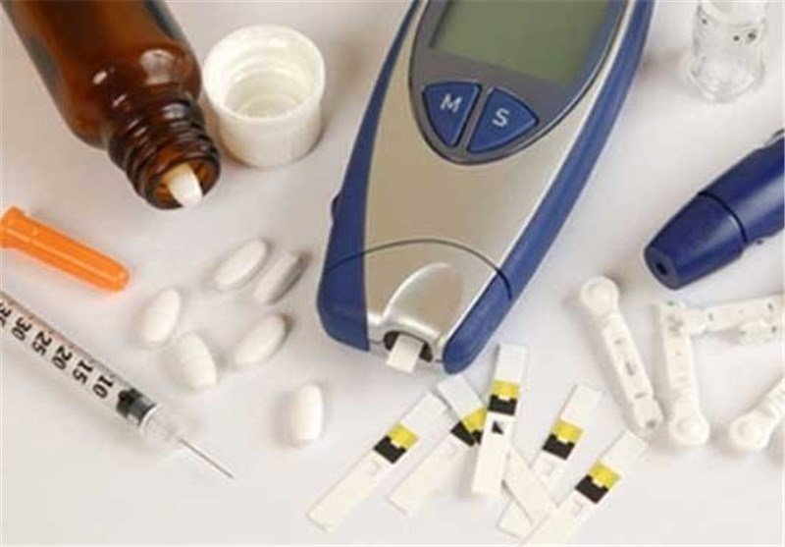



# **Situation 10: Card 1**

**Situation card**

**Front Back**

**Situation 10**

At 19:00, there is a dose of heparin due for administration, a therapy that the patient will have to continue for at least another 25 days (therefore most likely for a certain period of time, even at home, after discharge).

The nurse asks you to take care of it and informs you that, at the moment, the daughter is also present in the patients hospital room.



**What will you do?**





# **Situation 10: Card 2 (Answer A)**

# 

**Situation 10: Answer A**

**Front Back**

**CORRECT**

The nursing approach should always be integrated and holisitc, aimed at patient empowerment, and facilitating the continuity of care in safe conditions.

For further information on the subject, consult relevant Nursing Codes of practice, any specific Hospital guidelines or protocols, and/or Fundamental Nursing Care Frameworks as well as the scientific literature on the subject.



You plan an ‘educational intervention’ focused on teaching the subcutaneous administration of the Heparin (which will be addressed both to the patient and to his daughter). You explain your idea and discuss it with the nurse tutor

You enter the room, introduce yourself to the daughter and inform the patient that Heparin has been prescribed. After obtaining his consent and deciding it is appropriate to start the ‘educational intervention’, you explain what needs to be done, evaluating their willingness to be involved and encouraging them to ask questions in case of doubt.

After the drug has been administered, you evaluate the patient's ability to retain the information. Talking them through the procedure and reinforcing aspects where necessary. You then plan the self-administration goal with him and his daughter, defining a time frame and reassuring them that there will be nursing supervision as long as necessary.

# 

# **Situation 10: Card 3 (Answer B)**

**Situation 10: Answer B**

**Front Back**

**INCORRECT**

The nursing approach should always be integrated and holisitc, aimed at patient empowerment, and facilitating the continuity of care in safe conditions.



For further information on the subject, consult relevant Nursing Codes of practice, any specific Hospital guidelines or protocols, and/or Fundamental Nursing Care Frameworks as well as the scientific literature on the subject.

Enter the room and inform the patient that it is time for the Heparin injection that has been prescribed.

You administer the drug closely following the prescription and leave the room.

You know that the patient will be in the hospital for some days yet before he will be discharged home and that there are many other staff members who will take care of the patient's education regarding the Heparin – so it is best not to concern him with this at the present time.





# **Situation 11: Card 1**

**Situation card**

**Front Back**

**Situation 11**

At 8.00 pm the ward is quiet, due to the fact that 5 patients were discharged and the workload was reduced. This tranquillity is suddenly interrupted by shouting coming from the room of the patient you are caring for.

As soon as you enter, the patient's daughter asks if she can stay beyond visiting hours as her father seems "confused and scared", and because the other patient (with whom he shares the room) is constantly agitated and continues to shout.



**What will you do?**



# **Situation 11: Card 2 (Answer A)**

# 

**Situation11: Answer A**

**Front Back**

**CORRECT**

Active listening is essential in order to establish a relationship of trust with the patient and guarantee his safety, as well as quality care. Taking responsibility for the care of a patient implies availability and attention to his needs, so that any signs of situations or issues which may ‘endanger ‘ the patient can be detected early, and so effective interventions to protect his wellbeing and recovery can be planned and implemented.



For further information consult relevant Nursing Codes of practice, any specific Hospital guidelines or protocols, and/or Fundamental Nursing Care Frameworks as well as the scientific literature on the subject.

You discuss the situation with the nurse tutor to understand the patients daughter can allowed to stay beyond visiting hours, and to understand how to ensure the comfort of your patient.



# 

# E:\SLIPPS\slipps-194x230 - Copy.png

# **Situation 11: Card 3 (Answer B)**

**Situation 11: Answer B**

**Front Back**

**INCORRECT**

Active listening is essential in order to establish a relationship of trust with the patient and guarantee his safety, as well as quality care. Taking responsibility for the care of a patient implies availability and attention to his needs, so that any signs of situations or issues which may ‘endanger ‘ the patient can be detected early, and so effective interventions to protect his wellbeing and recovery can be planned and implemented.



For further information consult relevant Nursing Codes of practice, any specific Hospital guidelines or protocols, and/or Fundamental Nursing Care Frameworks as well as the scientific literature on the subject.

Reiterate to the patient's relative that the visiting time ends at 8pm and reassure her that her father will be well looked after and will be fine.







# **Situation 12: Card 1**

**Situation card**

**Front Back**

**Situation 12**

The next day, during morning ‘handover’ you are informed that during the night the patient presented sudden deficiencies on one side and speech problems but that these disappeared after an hour or so.

At the moment the patient does not manifest any neurological signs or symptoms but a CT scan will be needed. Given the patients gastro-intestinal function seems ok (Bowel sounds have been noted), the surgeon has authorized resumption of meals/feeding.

The nurse reminds you that the patient has been entrusted to you and therefore you need to take care of things.

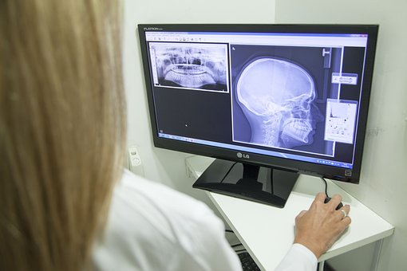

**What will you do?**





# **Situation 12: Card 2 (Answer A)**

# 

**Situation 12: Answer A**

**Front Back**

# 

**CORRECT**

Patient safety must always be a priority in care, during each stage of hospitalization. It is always advisable to consult with, and seek the support of, qualified staff when you feel unsure or ncertain about your skills and knowledge and if you feel you may not to possess the skills to guarantee patient safety.



For further information consult relevant Nursing Codes of practice, any specific Hospital guidelines or protocols, and/or Fundamental Nursing Care Frameworks as well as the scientific literature on the subject.

As a precautionary measure, you ask the nurse tutor to support you in resuming the patient's diet, to evaluate together any signs and symptoms of dysphagia



# E:\SLIPPS\slipps-194x230 - Copy.png

# **Situation 12: Card 3 (Answer B)**

**Situation 12: Answer B**

**Front Back**

**INCORRECT**

Patient safety must always be a priority in care, during each stage of hospitalization. It is always advisable to consult with, and seek the support of, qualified staff when you feel unsure or ncertain about your skills and knowledge and if you feel you may not to possess the skills to guarantee patient safety.



For further information consult relevant Nursing Codes of practice, any specific Hospital guidelines or protocols, and/or Fundamental Nursing Care Frameworks as well as the scientific literature on the subject.

Tell the patient that he can resume eating his meals and inform support staff







# **Situation 13: Card 1**

**Situation card**

**Front Back**

**Situation 13**

The patient is not suffering from dysphagia and the support staff have ordered a light diet.

The nurse tutor reminds you that you must ensure the patient has adequate nutrition and hydration.



**What will you do?**





# **Situation 13: Card 2 (Answer A)**

# 

**Situation 13: Answer A**

**Front Back**

# 

**CORRECT**

The objective of adequate feeding; nutrician and hydration of the patient is pursued through an approach that encourages the recovery of autonomy and maintaining control of the process: this implies that it is necessary to check whether the patient has eaten, if he has difficulties, and the amount of food taken.



For further information consult relevant Nursing Codes of practice, any specific Hospital guidelines or protocols, and/or Fundamental Nursing Care Frameworks as well as the scientific literature on the subject.

Verify that the meal delivered gives the required nutrition and encourage the patient to resume eating independently, helping him if there is a need.

At the end of the meal check the quantity and quality of food eaten and record this data in the nursing record





# **Situation 13: Card 3 (Answer B)**

**Situation 13: Answer B**

**Front Back**

**INCORRECT**

The objective of adequate feeding; nutrician and hydration of the patient is pursued through an approach that encourages the recovery of autonomy and maintaining control of the process: this implies that it is necessary to check whether the patient has eaten, if he has difficulties, and the amount of food taken.



For further information consult relevant Nursing Codes of practice, any specific Hospital guidelines or protocols, and/or Fundamental Nursing Care Frameworks as well as the scientific literature on the subject.

As the patient is autonomous and does not have problems related to eating you ask a member of the support staff (care assistant) to take care of the patients meals and nutrition.







# **Situation 14: Card 1**

**Situation card**

**Front Back**

**Situation 14**

The next day, the nurse on duty tells you that you need to make sure the patient is able to be discharged home safely.



**What will you do?**





# **Situation 14: Card 2 (Answer A)**

# 

**Situation 14: Answer A**

**Front Back**

# 

**CORRECT**

To ensure a patients safe discharge, and to reduce episodes of return to hospital, or episodes of clinical criticality at home, it is necessary to acquire as much information as possible about the patient's home environment.

This helps proactivly address any home circumstances which may pose a ‘risk’, and inform and advise the patient in the most appropriate way. It is essential to know if the patient can access domestic help, in order to activate any support services if necessary. All this must be done in advance of the expected discharge date, in order to have time to organize safe discharge.

For further information consult relevant Nursing Codes of practice, any specific Hospital guidelines or protocols, and/or Fundamental Nursing Care Frameworks as well as the scientific literature on the subject.

You go to the patient's room and after evaluating that it is the right moment you start a conversation with him aimed at understanding if he has any particular issues that need to be addressed so he can be discharged home, (for example does he have, or need a carer or domestic help to support him at home, does he need any special equipment etc).







# **Situation 14: Card 3 (Answer B)**

**Situation 14: Answer B**

**Front Back**



**INCORRECT**

To ensure a patients safe discharge, and to reduce episodes of return to hospital, or episodes of clinical criticality at home, you should gather as much information as possible about the patient's home environment and living conditions.

This helps proactivly address any home circumstances which may pose a ‘risk’, and enables you to advise the patient in the most appropriate way. It is essential to know if the patient can access domestic help, in order to activate any necessary support services. All this must be done in before discharge date, in order to have time to organize things for a safe discharge.

For further information consult relevant Nursing Codes of practice, any specific Hospital guidelines or protocols, and/or Fundamental Nursing Care Frameworks as well as the scientific literature on the subject.

You go to the patient's room and explain in detail the therapy and medication regime he will have to follow and undertake home.

You inform him he will receive his medications and be given guidance on exercise before he leaves.







# **Situation 15: Card 1**

**Situation card**

**Front Back**

**Situation 15**

After talking to the patient, you discover that at home the only support he has is from a privately hired caregiver, who is from another country and does not understand or speak the language very well.

Also, his daughter lives far away and can only visit her father at weekends.

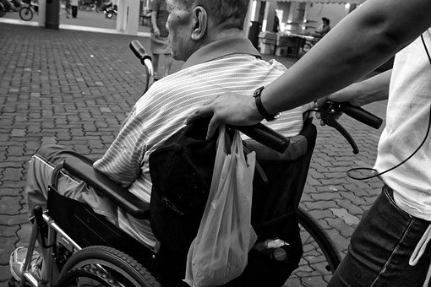

**What will you do?**





# **Situation 15: Card 2 (Answer A)**

# 

**Situation1 5: Answer A**

**Front Back**

# 

**CORRECT**

To ensure a patients safe discharge, and to reduce episodes of return to hospital, or episodes of clinical criticality at home, you should gather as much information as possible about the patient's home environment and living conditions.

This helps proactivly address any home circumstances which may pose a ‘risk’, and enables you to advise the patient in the most appropriate way. It is essential to know if the patient can access domestic help, in order to activate any necessary support services. All this must be done in before discharge date, in order to have time to organize things for a safe discharge.

For further information consult relevant Nursing Codes of practice, any specific Hospital guidelines or protocols, and/or Fundamental Nursing Care Frameworks as well as the scientific literature on the subject

At the end of the conversation go to report these problems to the nurse tutor.

You discuss these issues with the tutor and try to understand what can be done to ensure safe discharge: activation of home service, consultancy of an interpreter, follow-up from community nursing staff, etc.







# **Situation 15: Card 3 (Answer B)**

**Situation 15: Answer B**

**Front Back**

**INCORRECT**

To ensure a patients safe discharge, and to reduce episodes of return to hospital, or episodes of clinical criticality at home, you should gather as much information as possible about the patient's home environment and living conditions.

This helps proactivly address any home circumstances which may pose a ‘risk’, and enables you to advise the patient in the most appropriate way. It is essential to know if the patient can access domestic help, in order to activate any necessary support services. All this must be done in before discharge date, in order to have time to organize things for a safe discharge

 For further information consult relevant Nursing Codes of practice, any specific Hospital guidelines or protocols, and/or Fundamental Nursing Care Frameworks as well as the scientific literature on the subject

Given the language difficulties with the caregiver, you decide to provide verbal information to the patient on how to behave and what to say to the caregiver.





